**Financial Service Consultants**

Project Overview

The project is build using following technologies and tools

* Dot net Core 1.1
* Swagger
* Entity Framework Core 1.1.2
* jQuery
* Visual Studio 2017 Community

First time opening the project

Run the following commands to get all dependencies using package manager console.

* ‘dotnet restore’
* ‘dornet build’

Restoring Database

Run the following commands to get all dependencies using package manager console.

* ‘dotnet ef database update’

Note:

The project is configured to use localdb as is default database.

Connection strings can be found in ‘appsettings.json’.

To use MSSQL connection string change the following in ‘startup.cs’

// Add Entity Framework

services.AddDbContext<ApplicationDbContext>(options =>

options.UseSqlServer(Configuration.GetConnectionString("MSSQLConnection")), ServiceLifetime.Transient);

Launching the project

The project is configured with two profile

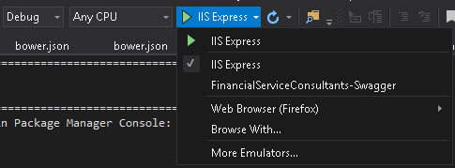

IIS Express will launch the UI interface

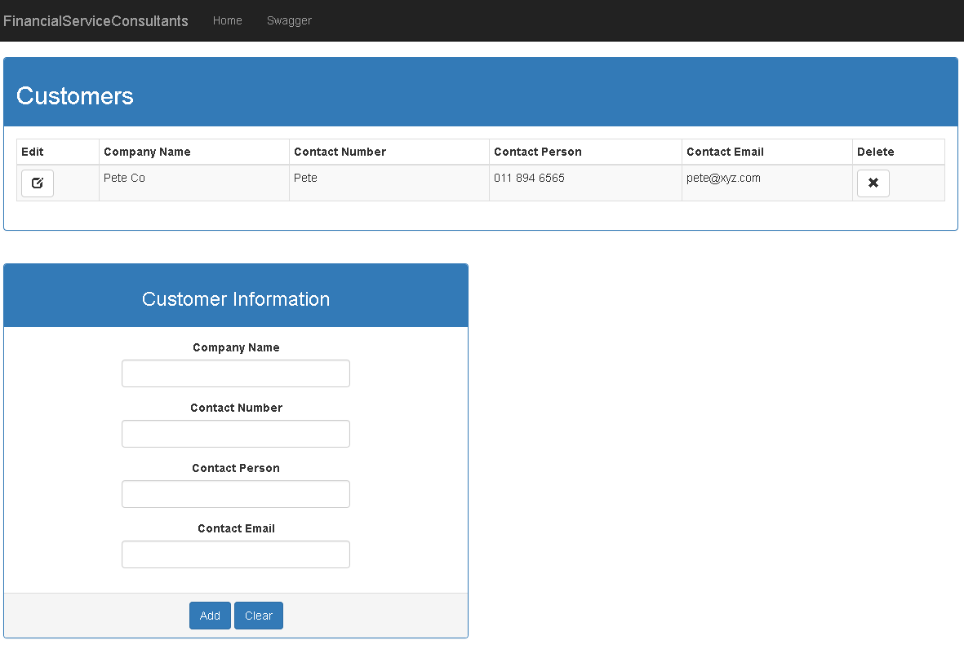

FinancialServiceConsultants-Swagger will launch Swagger UI exposing the Web API

